Document Attributes

| Attribute | Value |
| --- | --- |
| Application ID / Application Name | BPP - CKT-VOICE |
| Owner | Rahul Bathla |
| Owner Contact Information | RB824N |
| Problem Abstract | Cannot Issue WORD |
| Other Attribute |  |

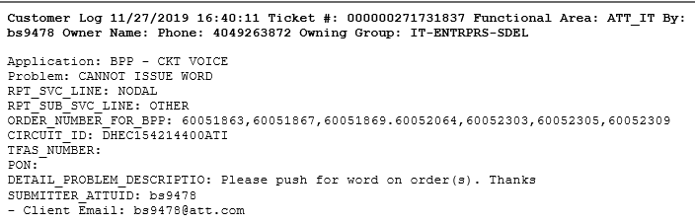

1. Go to under mentioned link and check the information on Orders in “SIFUSO” Table

SELECT * FROM SIFUSO WHERE ORDER_NO in ('60051863','60051867','60051869','60052064','60052303','60052305','60052309')

<http://bppcktv.it.att.com:8000/sql/index.html>

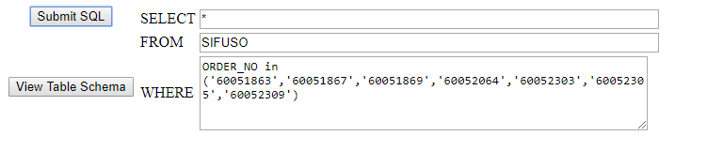

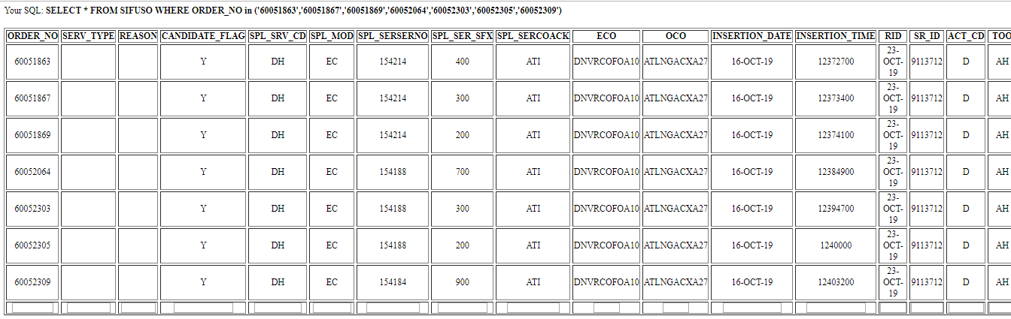

1. Go to Get- GUI Page (Link below)

<http://bppcktv.it.att.com:8000/prod-sup/>

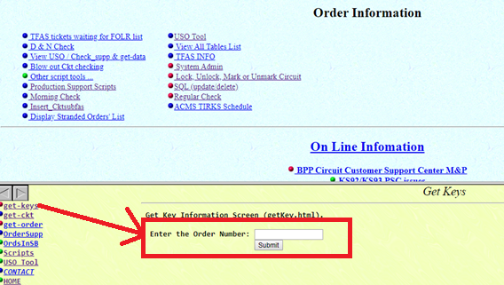

1. Put an order number there as highlighted in the image below

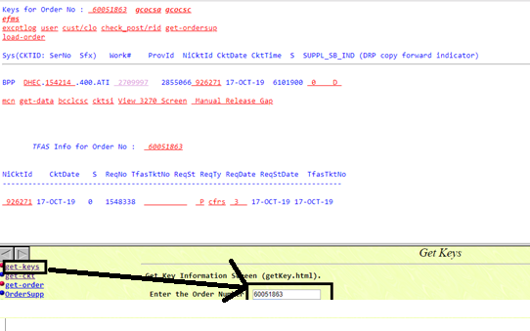

1. Click the highlighted link below to check if it is Disconnect Or Quick release disconnect Order.

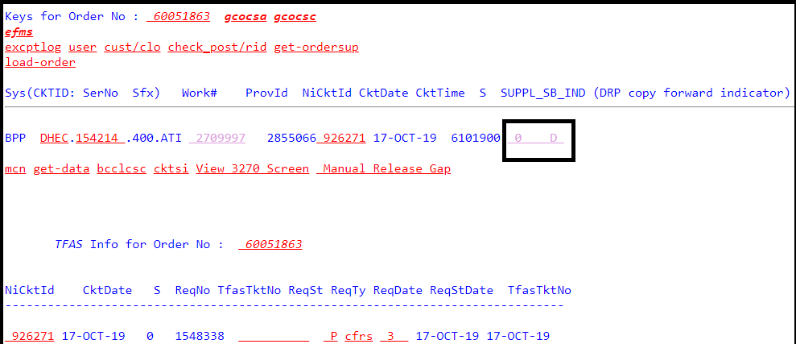

1. Once you perform Step 4 you see screen below. When we see ECO Code DNVR and OCO code ATLN- it mean it is QRD- Quick release disconnect- These orders don’t get TFAS number, so we can directly jump to issue WORD.

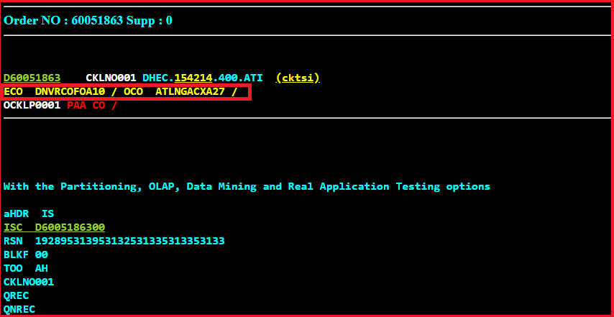

1. We will go to COMPREQ Table using (<http://bppcktv.it.att.com:8000/sql/index.html>)

We will change the TFAS Status from P to E, using Update command in GUI

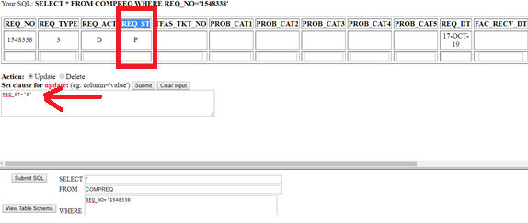

1. Next step will be to get back to GUI Info page and see if the status has changed as displayed in screen shot Below

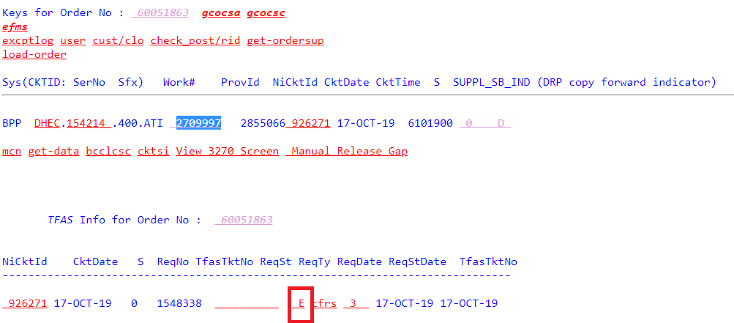

1. Now we will go to Production Script Page using the link below and go for “tgo2sb” which is a script of scheduling block. The scheduling block number for issuing WORD is 0820. <http://bppcktv.it.att.com:8000/prod-sup/wrapper/ps-index.html>

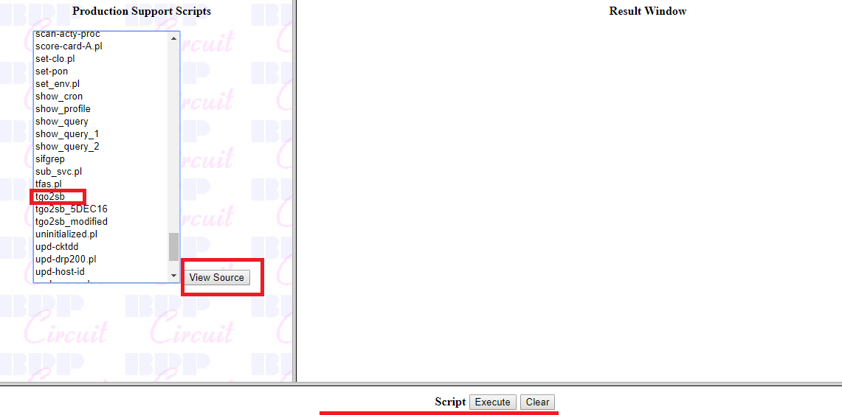

1. We run the command using 0820 WORK Number from GUI Page

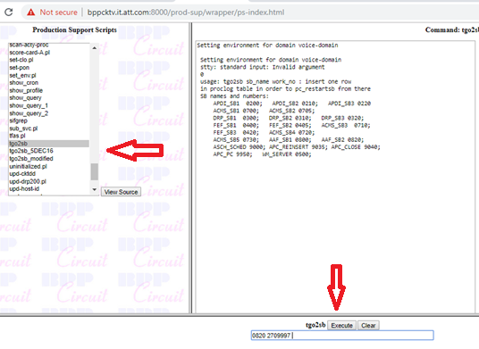

**Below are the logs after running the command**

Setting environment for domain voice-domain

Setting environment for domain voice-domain

stty: standard input: Invalid argument

2

SQL*Plus: Release 11.2.0.4.0 Production on Fri Nov 29 09:45:27 2019

Copyright (c) 1982, 2013, Oracle. All rights reserved.

Connected to:

Oracle Database 11g Enterprise Edition Release 11.2.0.4.0 - 64bit Production

With the Partitioning, OLAP, Data Mining and Real Application Testing options

SQL> SQL> SQL>

1 row deleted.

SQL>

1 row deleted.

SQL> SQL> 2 3 4 5 6 7 8 9

1 row created.

SQL> SQL>

0 rows updated.

SQL>

0 rows deleted.

SQL> SQL>

SB_SRV_NAME WORK_NUMBER PROV_ACT_ID SCHD SCHD UNAME NI_CKTID

--------------- ----------- ----------- ---- ---- ---------- ----------

CKT_SUBD_NO CKL_ CKT_DATE CKT_TIME SUPPL_SEQ_NO ACTUAL PROCESS_LVL R S PRV_

----------- ---- --------- ---------- ------------ ------ ----------- - - ----

PRV_

----

AAF_SB2 2709997 2855066 0820 0000 zlp10984 926271

0001 17-OCT-19 6101900 0 000000 30 0 9950

0000

SQL> SQL> Disconnected from Oracle Database 11g Enterprise Edition Release 11.2.0.4.0 - 64bit Production

With the Partitioning, OLAP, Data Mining and Real Application Testing options

*** Start runnig job pc_restartsb 2709997

tgo2sb -- job has completed...

1. Next step will be to check if WORD has been issue successfully, for that we will need ProvID (Provisional ID) Number highlighted in Screen shot below.

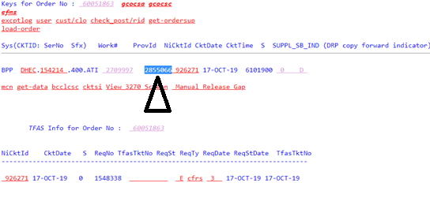

1. We will go to table “NCDIF” table using link below.

Query will be SELECT*FROM NCDIF WHERE PROV_ACT_ID=’2855066’

<http://bppcktv.it.att.com:8000/sql/index.html>

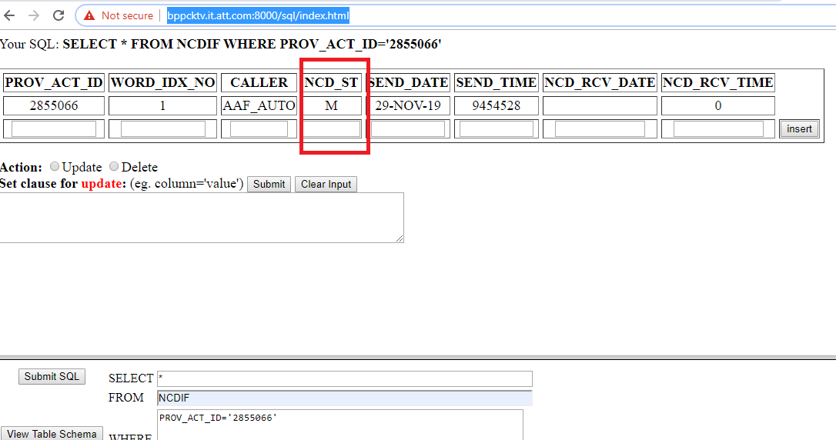

If you see in above screen shot NCD_ST is “M”, which means WORD has not gone through. If WORD get issued successfully then this status is “S”

1. We will go back to Order info page and click the highlighted “except log” hyperlink to see what is the error.

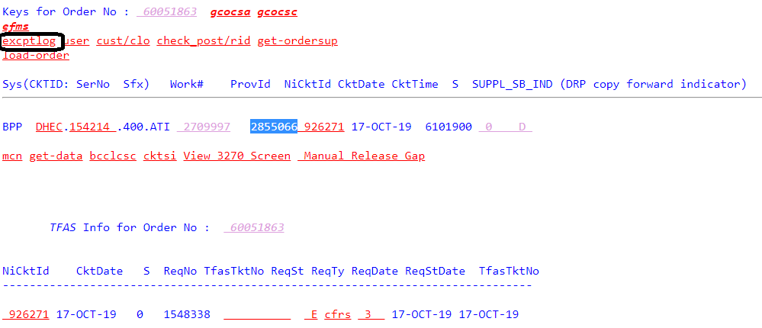

1. This what you see after clicking the hyper link- you also see another major Trouble ticket which says Missing “4EAPOT”. Walkthrough that issue is at the fixing that Issue. That will also be covered later in document

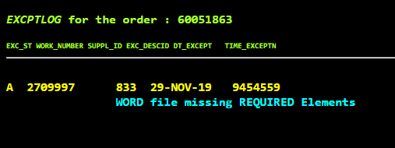

1. To fix this error we will need to add LSO line in Table CKLACCLOC using query with NICCKT Id from Get GUI

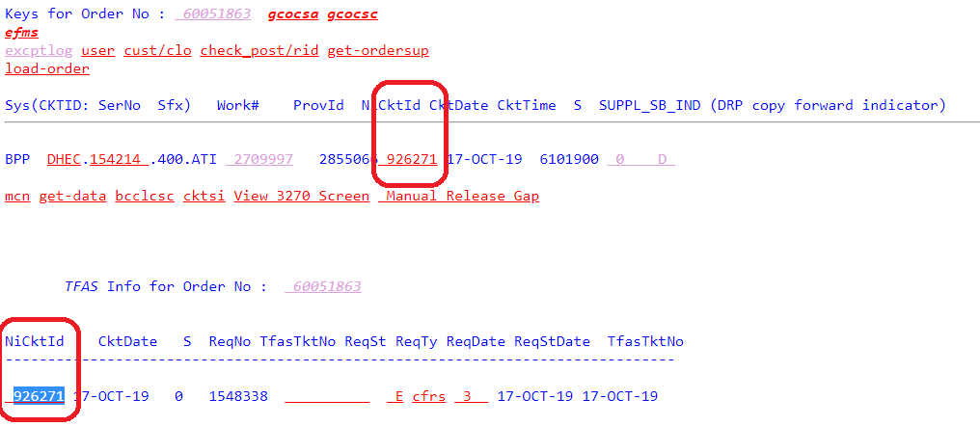

1. Page go SQL using link below, using Query SELECT * FROM CKLACCLOC WHERE NI_CKTID='926271'

<http://bppcktv.it.att.com:8000/sql/index.html>

When a WORD File is Missing we Add LSO line and when A 4EAPOT is missing we add 4EAPOT.

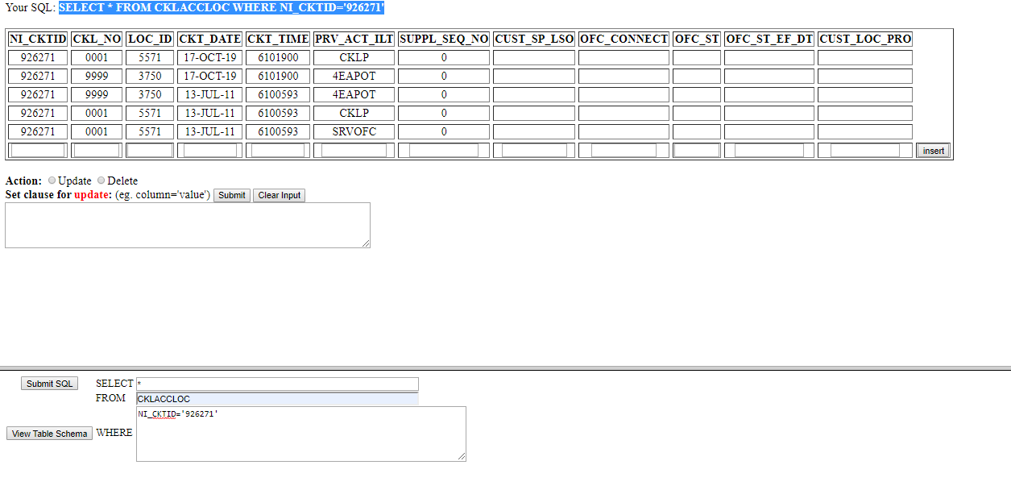

1. Add line as highlighted above. If there is any LSO Line available earlier use values from that line except Time Stamp. Or Use value from PRV_ACT_ILT “4EAPOT” Line but make sure always get latest time Stamp and CKL_NO value will be “0001” if otherwise mentioned in LSO Line and Insert

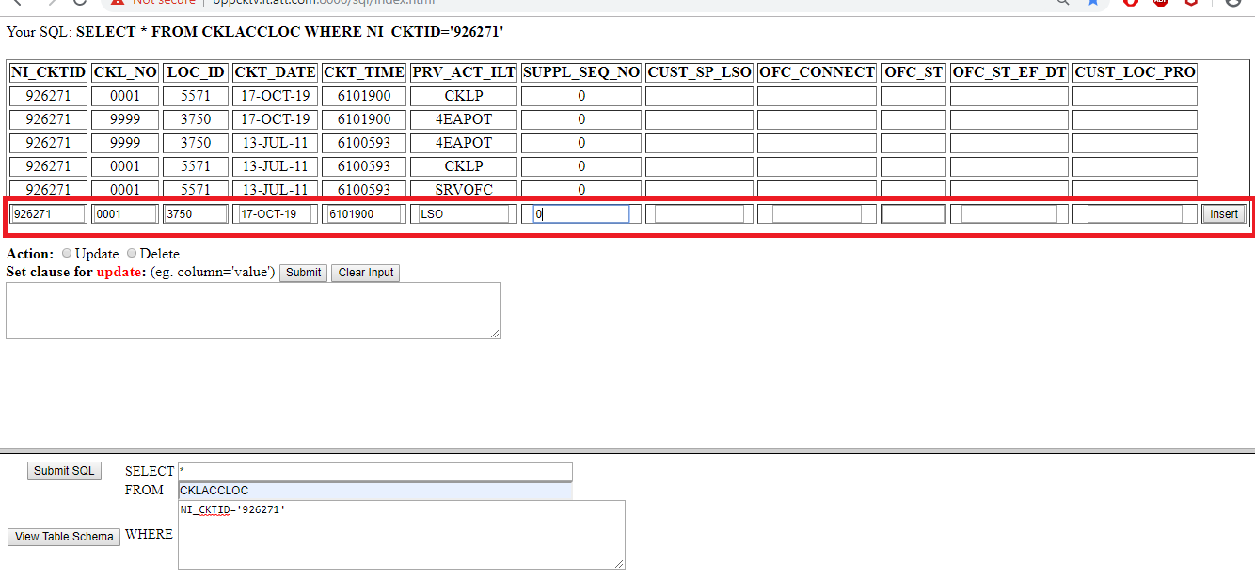

1. Go back to Step 9 to try and generate WORD using t2gso Production script.

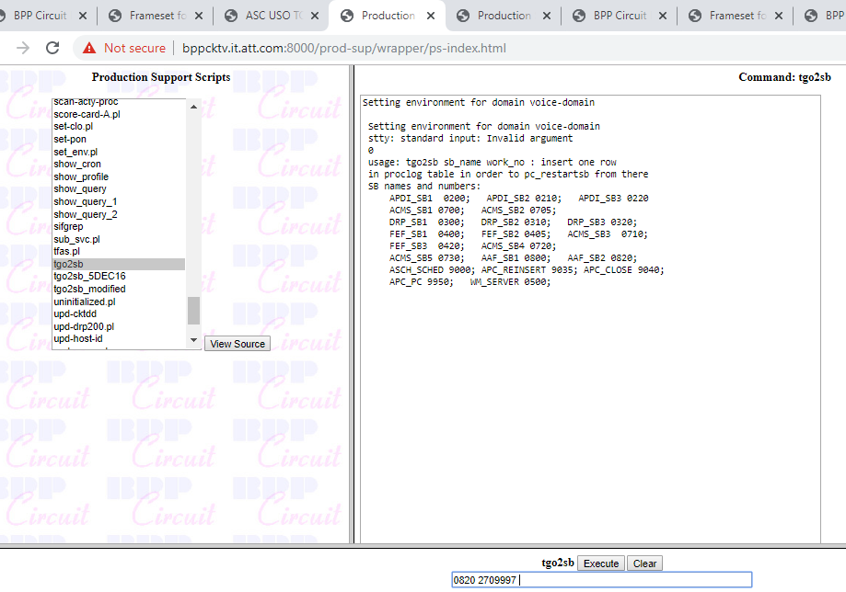

1. Go to step 10 & 11 and go to table “NCDIF” table using link below.

Query will be SELECT*FROM NCDIF WHERE PROV_ACT_ID=’2855066’

<http://bppcktv.it.att.com:8000/sql/index.html>

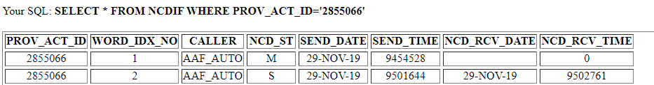

Once NCD Status for PROV_ACT_ID in NCDIF table is “S”. which means WORD has been issued successfully .

**THIS SECTION IS FOR MISSING 4EAPOT**

13. Page go SQL using link below, using Query SELECT * FROM CKLACCLOC WHERE NI_CKTID='926271'

<http://bppcktv.it.att.com:8000/sql/index.html>



14. Add line as highlighted above. If there is any 4EAPOT Line available earlier use values from that line except Time Stamp. Or Use value from PRV_ACT_ILT “4EAPOT” Line but make sure always get latest time Stamp and CKL_NO value will be “0001” if otherwise mentioned in 4EAPOT Line and Insert

NI_CKTID, CKL_NO, LOC_ID, CKT_DATE, CKT_TIME, PRV_ACT_ID and SUPPL_SEQ_NO.

- PRV_ACT_ID will be '4EAPOT'

- CKL_NO and LOC_ID as specified above (Note: The CKL_NO can be either 0001, 0002 or 9999. 0001 often works best)

- The remaining values will be taken from the most current order line



1. Go back to Step 9 to try and generate WORD using t2gso Production script.



1. Go to step 10 & 11 and go to table “NCDIF” table using link below.

Query will be SELECT*FROM NCDIF WHERE PROV_ACT_ID=’2855066’

<http://bppcktv.it.att.com:8000/sql/index.html>

